AMANDA LEHMANN - Biography

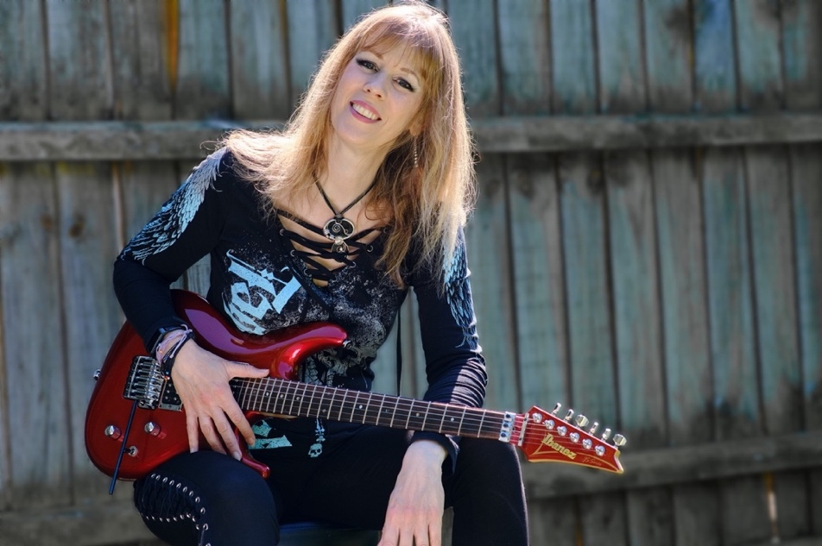

PROG Magazine Top Ten Female Vocalist, 2021
“Her compositions, guitar work and distinctive vocals are superb.”
(DPRP, The Netherlands)

Amanda Lehmann is an international solo recording artist, performer, composer, singer and guitarist, also known for her collaborations with former Genesis guitarist, Steve Hackett.
After a musical career spanning over three decades, singer/songwriter/guitarist Amanda released her debut solo album Innocence and Illusion in 2021. The recording, which features 9 songs, sees a fusion of prog, rock, ballads, and elements of jazz-blues, takes us on a journey through magical childhood worlds and hard-edged realities; emotionally touching us at every turn.
Amanda showcases her album & music from her back catalogue in live acoustic shows, bringing the essence of her songs to the audience in a captivating and personal performance.
“A true English Rose. Uplifting… “Monsters” finishes the set to rapturous applause and a standing ovation.” (Kenny Brown for TWR Online, UK)
Her gigging career has incorporated thousands of live shows, performing extensively around the UK with her own band in the 80s and 90s and latterly touring with Steve Hackett between 2009 – to date.
“Playing live shows is always such a joy for me… generating a musical energy that bonds the player and the audience, it’s absolute magic” (Amanda Lehmann)

She has previously released a solo EP ‘Shadow’ in 2010, and a duo album ‘Wazzoon’ in 1994 (remastered 2021). In 2022, Amanda released a Christmas single ‘An Old Christmas Day, and also a single ‘One Last Spin’ which she wrote to complement a film documentary to highlight the issue of gambling harms. Amanda also enjoys collaborating with other musicians and features on many musical projects.
The Sussex-born, now Norfolk resident has always adored singing, and throughout her childhood would grab any opportunity to sing whether in a solo capacity or as part of a choir. As a teenager, she began to study the styles of various vocalists from Stevie Nicks to Pat Benatar; Alison Moyet to Joni Mitchell, to work out what techniques they used and forging a vocal style of her own. “My vocals are always adapting” says Amanda “I like to vary my style according to the song I’m singing; different techniques work for different songs. I particularly love constructing multi-layered harmonies.”
“…vocal similarities to those of ground-breaking British singer-songwriter Kate Bush and the Wilson sisters in Heart abound” (The Grateful Web.com, USA )

Originally classically trained on the piano, Amanda fell in love with the power of the overdriven guitar. Self-taught, she went ahead and learnt tricks and tips from experienced players, all the time creating a style combining influences of rock, blues and folk. “You never stop learning” says Amanda “which is part of the joy of music.”

“… her fluid emotive playing is sublime … her voice is poignant and moving.” (John Wenlock-Smith, Progradar, UK)

www.amandalehmann.co.uk/
www.facebook.com/AmandaLehmannMusic
Twitter: @amandalehmann25
www.instagram.com/amandalehmannmusic/
https://www.youtube.com/channel/UChDK6Pqgs2Kco25NMT1WWIw
Tenacity. Publicity By Perseverance…
P.O.Box 166, Hartlepool TS26 9JA UK Dave: +44 (0)7951 679666 tenacitymusicpr@gmail.com

